**EXPERIMENT 1.1**

**Student Name: Milan Sharma UID: 23MAI10003**

**Branch: ME – CSE - AIML Section/Group: 23MAI – 1 (A)**

**Semester: 2nd Date of Performance: 1 Jan 2024**

**Subject Name: Soft Computing Lab Subject Code: 23 CSH 653**

**Aim :**

a) Implementation of fuzzy controller (Washing Machine)

b) Implementation of Fuzzy controller of Automatic Braking System

c) Implementation of Fuzzy controller of Fast Charging System

**Theory :**

**Control System:**

Any system whose outputs are controlled by some inputs to the system is called control system.

**Fuzzy Controller:**

A fuzzy controller is a type of control system that uses fuzzy logic to control a dynamic system. Unlike traditional control systems that rely on precise mathematical models, fuzzy controllers handle uncertainty and imprecision by using linguistic variables and fuzzy rules. Fuzzy logic allows the system to work with approximate reasoning and make decisions based on vague or ambiguous information.

A fuzzy controller typically consists of three main components:

1. **Fuzzification:** This process involves converting crisp input values into fuzzy sets. Fuzzy sets represent the degree of membership of an input in a particular linguistic term. For example, if the input is "temperature," fuzzy sets might include "low,""medium," and "high."
2. **Inference Engine:** The inference engine applies fuzzy logic rules to the fuzzy sets obtained from fuzzification to determine the fuzzy output sets. These rules are typically expressed in the form of "if-then" statements, where the "if" part corresponds to certain conditions and the "then" part to the resulting action.
3. **Defuzzification:** The fuzzy output sets obtained from the inference engine are converted back into crisp values for the system's output. This process involves aggregating the fuzzy sets and finding a single, crisp output value.

**Fuzzy Sets:**

Fuzzy sets are used to represent linguistic variables, which are qualitative terms that describe the state of system. For example, in a temperature control system, linguistic variables could be like "hot,""cold," or "warm."

**Fuzzy Output:**

Fuzzy output refers to the result or decision produced by a fuzzy logic controller. In a fuzzy logic system, the output is often expressed in terms of linguistic variables and fuzzy sets, reflecting the imprecision and uncertainty inherent in the system.

**A) IMPLEMENTATION OF FUZZY CONTROLLER (WASHING MACHINE)**

Design a controller to determine the wash time of a domestic washing machine. Assume the input is dirt and dirtness type (grease) on clothes. Use two descriptors for input variables and five descriptors for controller action and defuzzification.

Steps to solve:

1. Identify input and output variables and decide descriptor for the experiment.
2. Define the membership function for each input and output variable.
3. Form a rule base.
4. Defuzzification or Final Result.

Identify input and output variables and decide descriptor for the experiment-

Inputs are “Dirt” and “Dirt Type (Grease)”. - Assume they are in percentage

Output is “Wash time” measured in a minutes.

Descriptor for input variable -

|  |  |
| --- | --- |
| **Dirt** | **Dirt Type (Grease)** |
| SD: Small dirt | NG : No grease |
| MD: Medium dirt | MG: medium grease |
| LD: Large dirt | LG: Large dirt |
| {SD,MD,LD} | {NG,MG,LG} |

Descriptor for the output variable –

|  |
| --- |
| **Wash time** |
| VS: Very short |
| S: short |
| M: Medium |
| L: Large |
| VL: Very Large |
| {VS,S,M,L,VL} |

Procedure –

1. Inputs and Outputs –

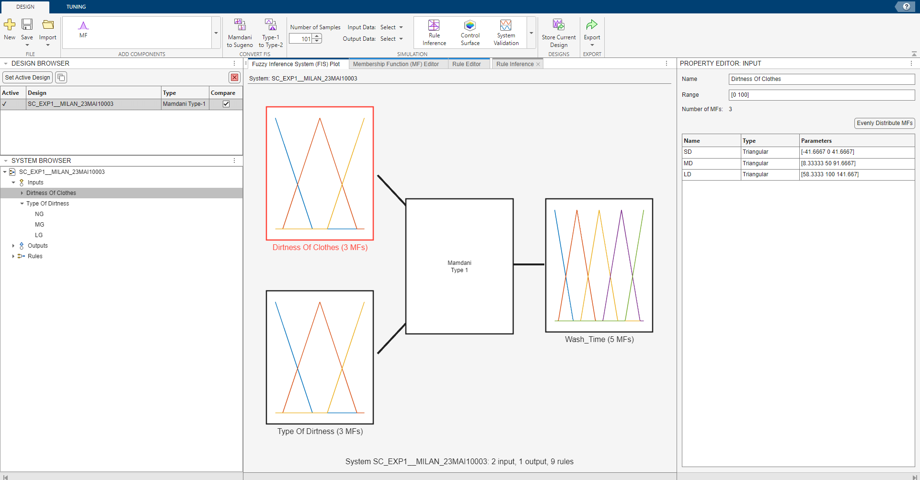

1. Membership Function for each Input and Output-

* MF for Dirtness-

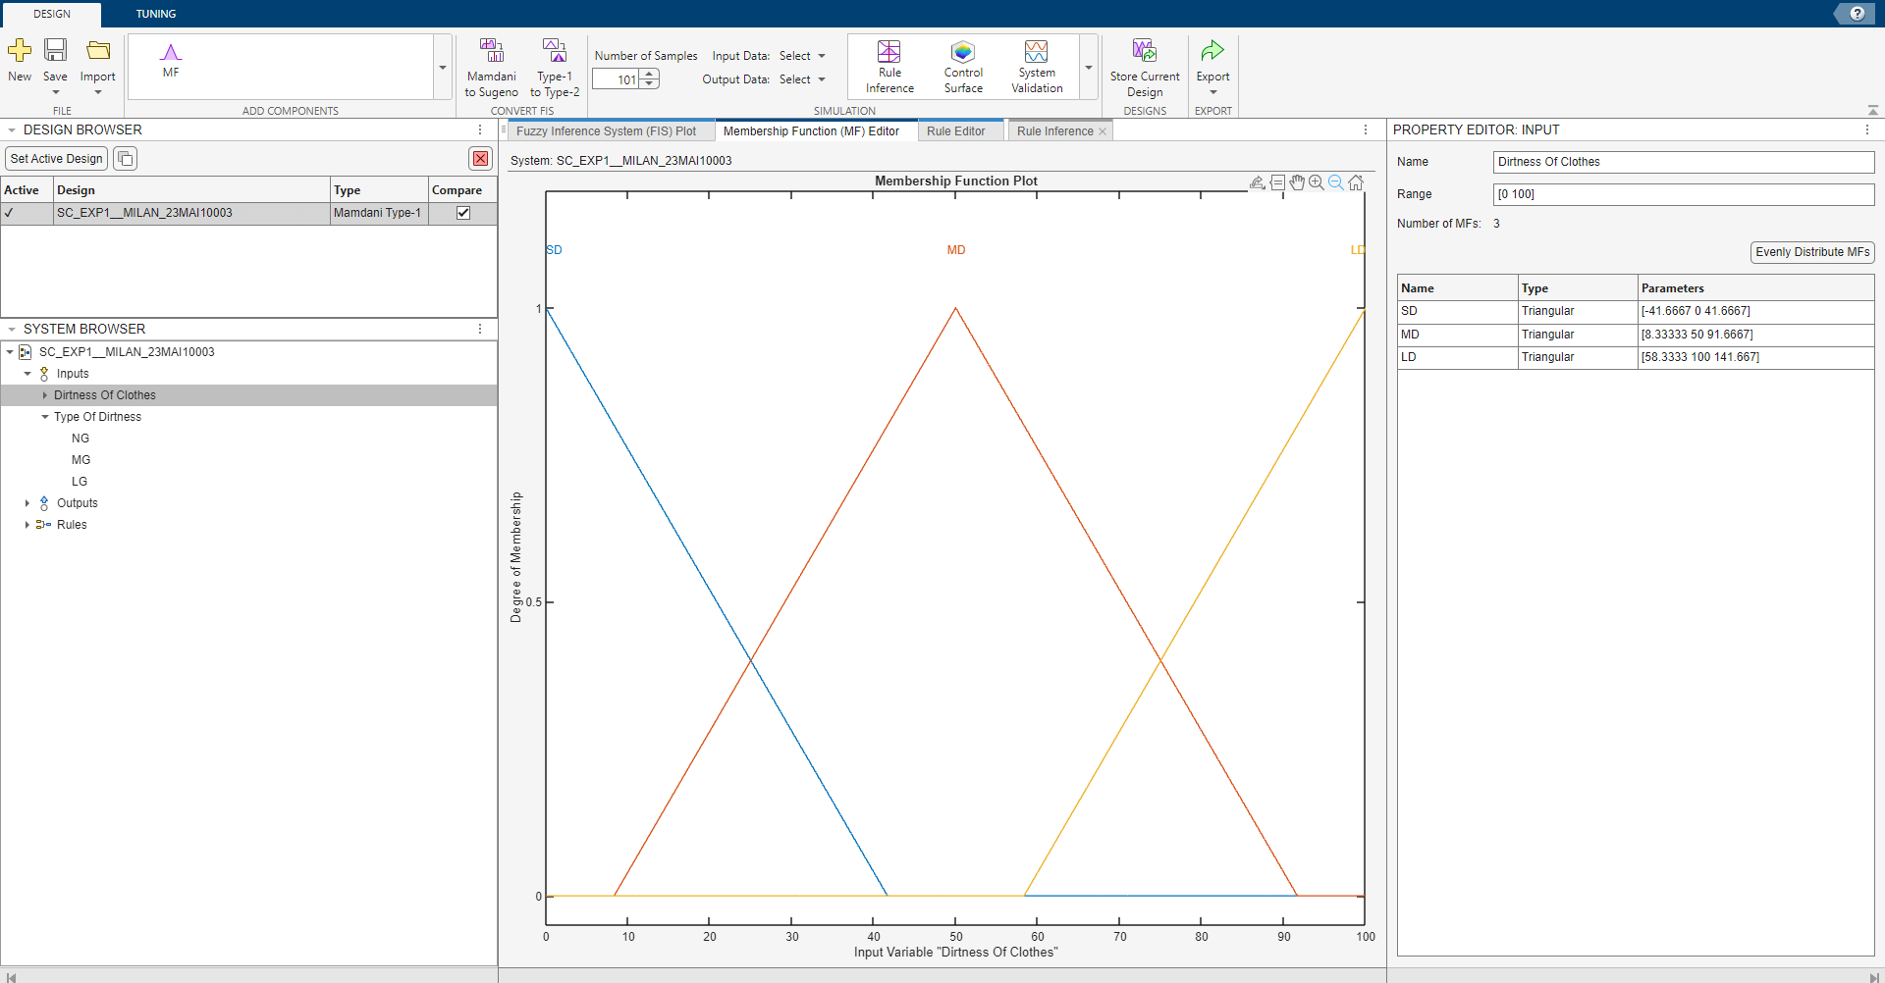

* MF for Dirtness Type (Grease) -

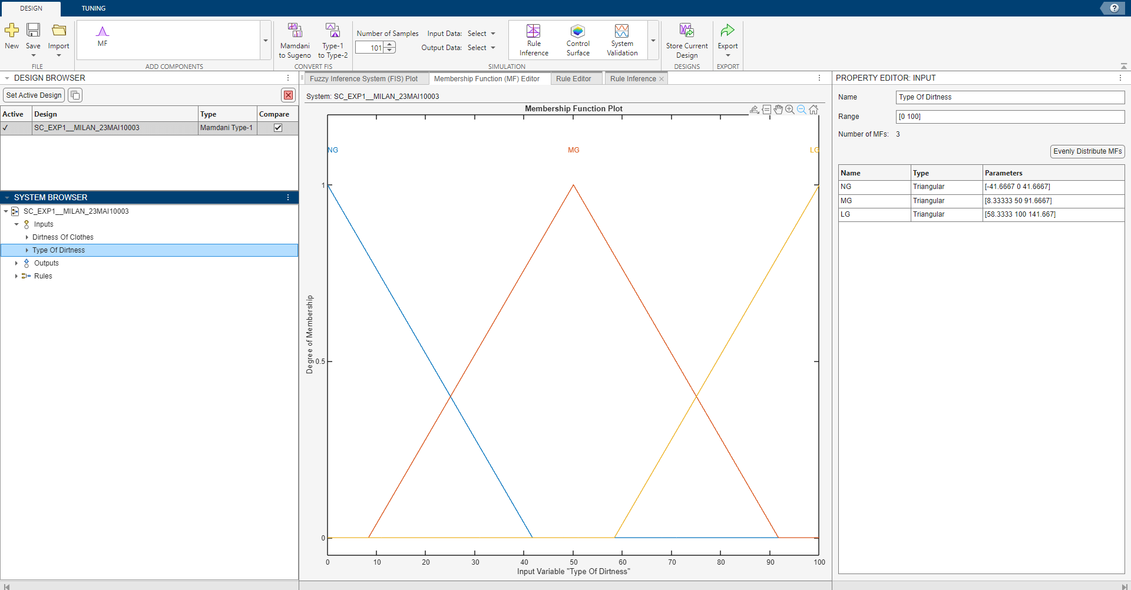

* MF for Wash Time -

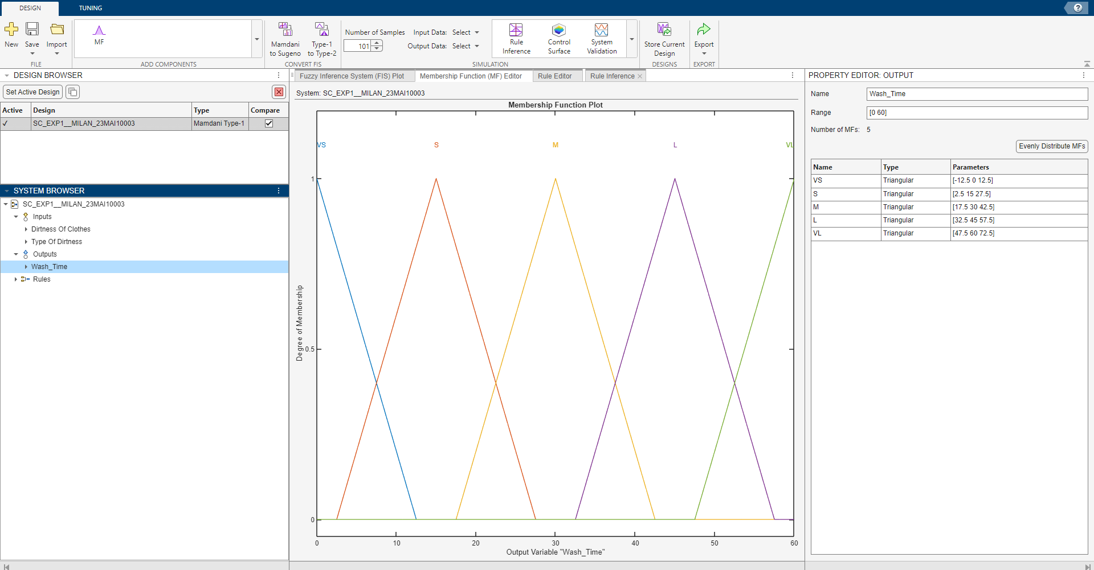

1. Forming Rule Base –

SD MD LD

|  |  |  |
| --- | --- | --- |
| VS | S | M |
| M | M | L |
| L | L | VL |

NG

MG

LG

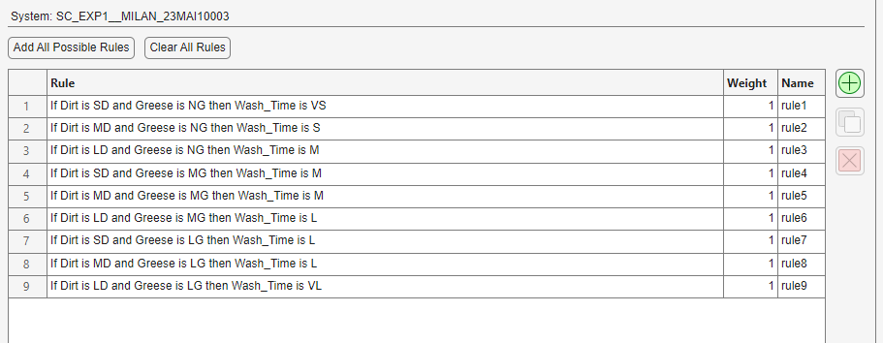

1. Evaluation at Dirt is 60% and Type is 70% -

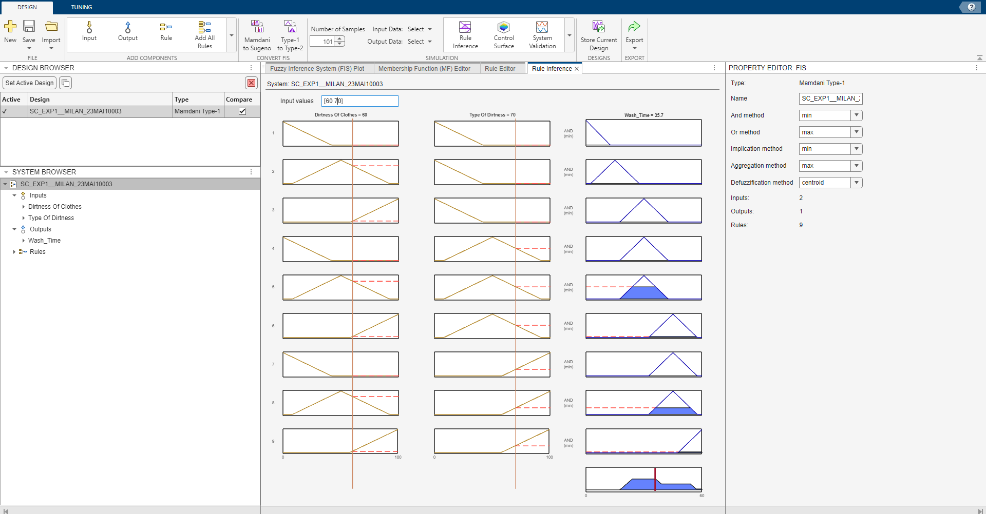

**B) IMPLEMENTATION OF FUZZY CONTROLLER OF AUTOMATIC BRAKING SYSTEM**

An Automatic Brake Control System, The speed and distance are inputs to a controller which outputs a control force to adjust the brake applied.

Depending upon the speed and distance, the brake is applied automatically. Fuzzy controller works in shades of gray where the speed and distance are treated as a series of overlapping ranges. The controller is programmed with simple if-then rules that tell the controller how hard the brake is applied. As a result, when the speed or distance changes, the brake will continuously adjust.

Steps to solve:

1. Identify input and output variables and decide descriptor for the experiment.
2. Define the membership function for each input and output variable.
3. Form a rule base.
4. Defuzzification or Final Result.

Identify input and output variables and decide descriptor for the experiment-

Inputs are “Speed” and “Distance”. - Assume they are in Km/hr and feet.

Output is “Brake Pressure”.

Descriptor for input variable -

|  |  |  |  |
| --- | --- | --- | --- |
| **Speed** | **Crisp input Range(Km/hr)** | **Distance** | **Crisp input Range(feet)** |
| DSL | 0-40 | ECL | 0-30 |
| VSL | 20-60 | VCL | 20-40 |
| SL | 40-80 | CL | 30-50 |
| MSL | 60-100 | MD | 40-60 |
| FST | 80-120 | FAR | 50-70 |
| VFS | 100-140 | VFAR | 60-80 |
| EFS | 120-160 | EFAR | 70-100 |
| {DSL (Dead Slow), VSL, SL, MSL, FST, VFS and EFS (Extremely Fast)} |  | {ECL,VCL,CL,MD,  FAR,VFAR,EFAR} |  |

Descriptor for the output variable

|  |
| --- |
| **Brake** |
| Release |
| VLP |
| LP |
| MP |
| HP |
| VHP |
| EHP |
| {RELEASE, VLP, LP, MP, HP, VHP and EHP } |

Procedure –

1. Inputs and Outputs–

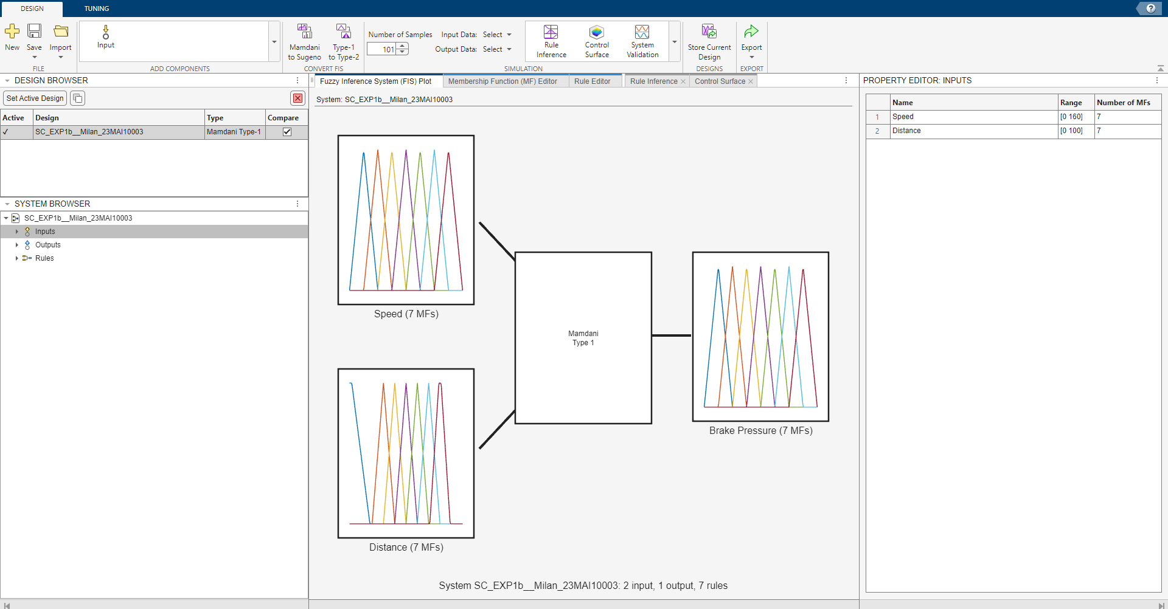

1. Membership Function for each Input and Output-

* MF for Speed -

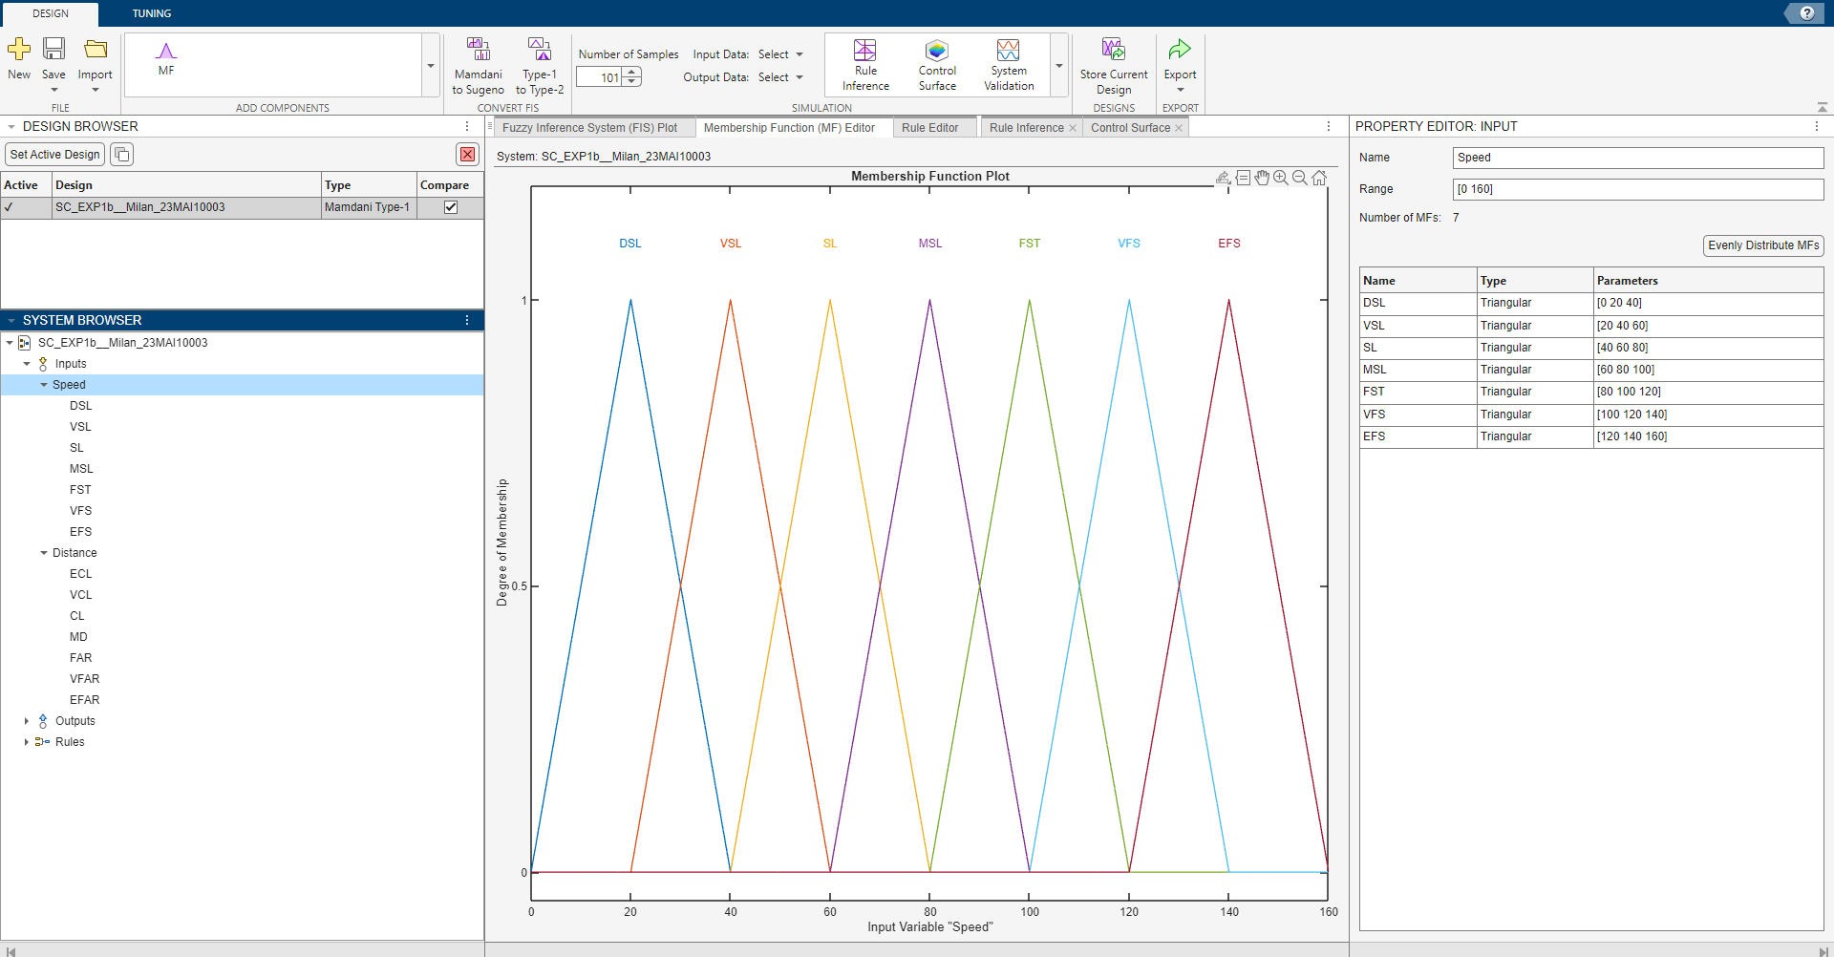

* MF for Distance -

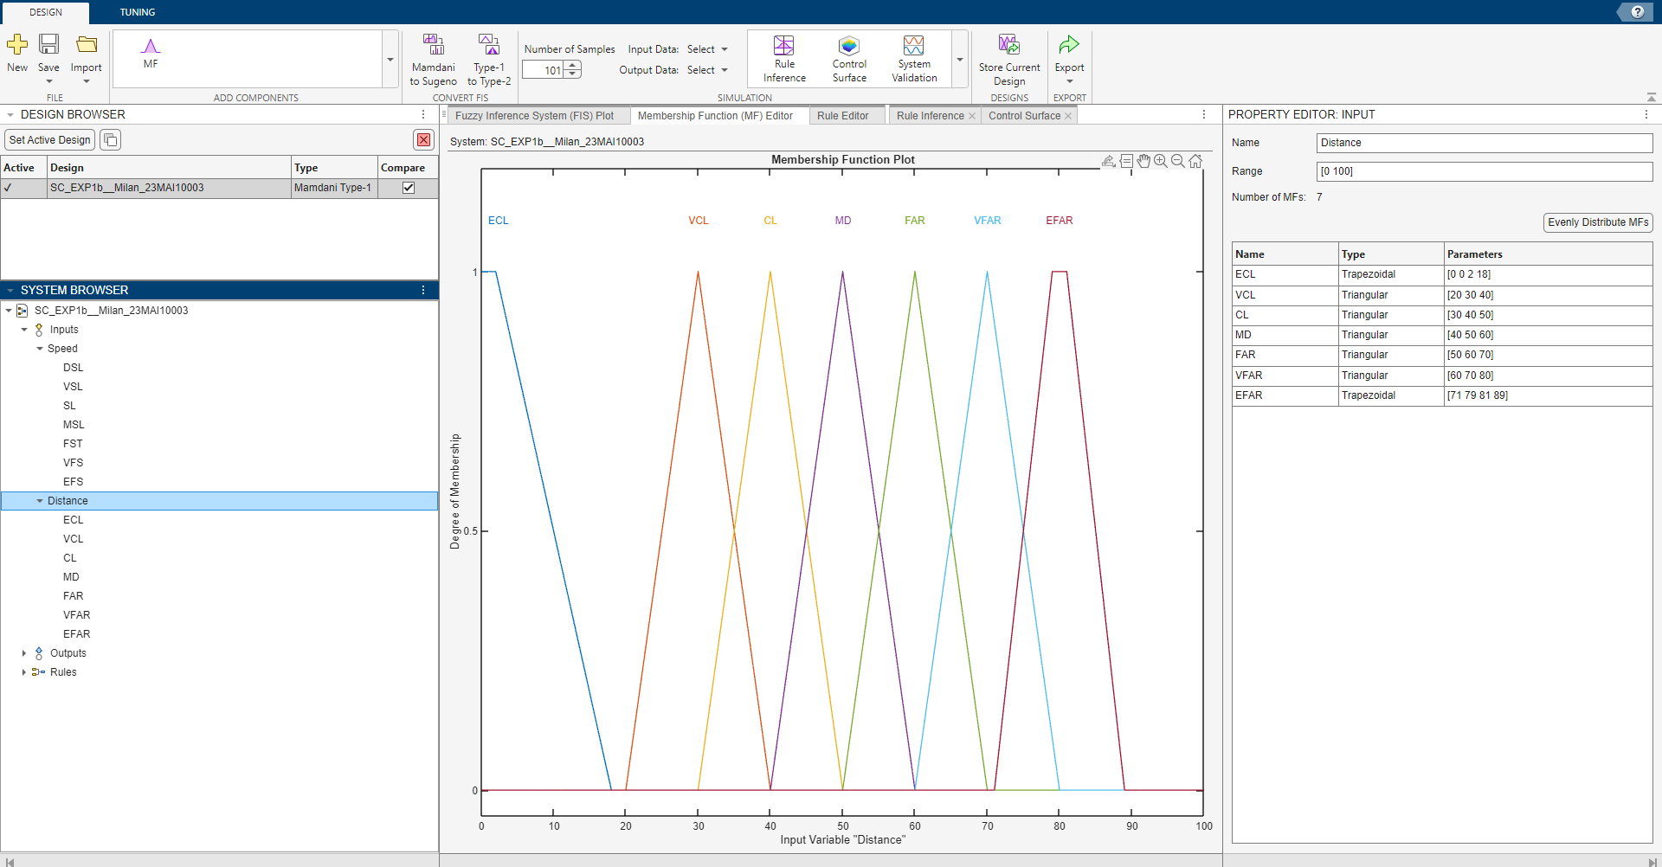

* MF for Break Pressure -

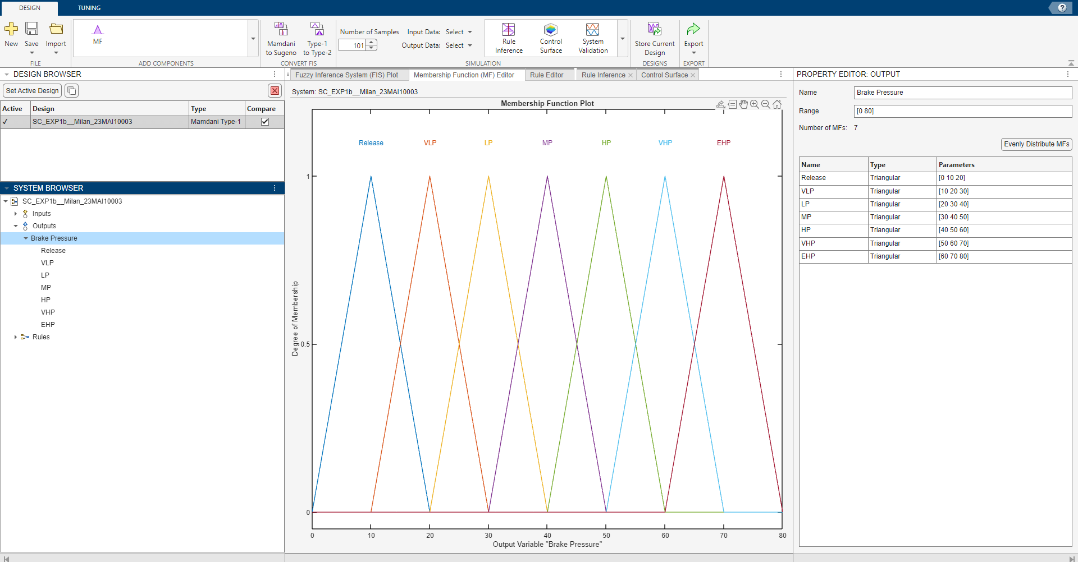

1. Forming Rule Base –

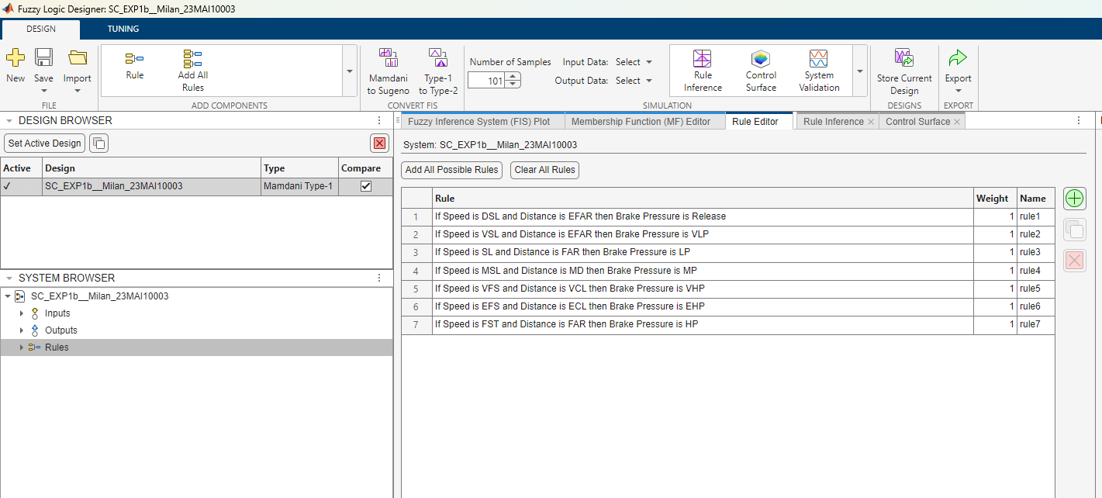

1. Evaluation at Speed is 80 and Distance is 50 –

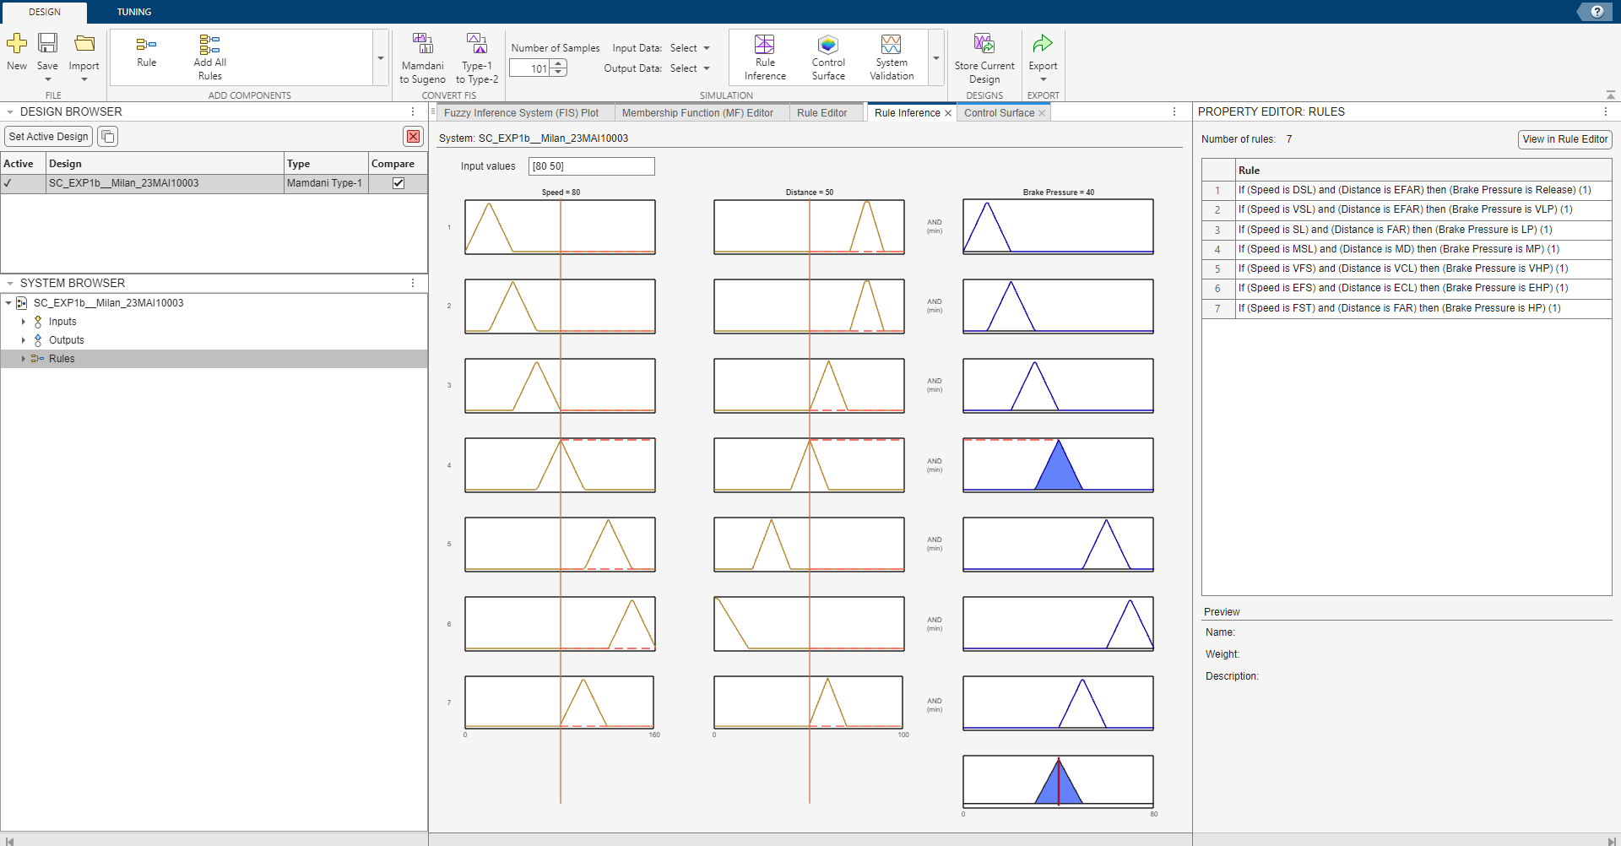

**C) IMPLEMENTATION OF FUZZY CONTROLLER OF FAST CHARGING SYSTEM**

An Automatic Charging Time Calculation System, The battery level, temperature and charging current are inputs to a controller which outputs the calculation of the time taken by battery to be fully charged.

Depending upon the battery level, temperature and charging current, the time taken is calculated automatically. Fuzzy controller works in shades of gray where the battery level, temperature and charging current are treated as a series of overlapping ranges. The controller is programmed with simple if-then rules that tell the controller how much time is taken to charge a full battery which is measured in hours. As a result when the battery level, temperature and charging current changes the time will continuously change.

Steps to solve:

1. Identify input and output variables and decide descriptor for the experiment.
2. Define the membership function for each input and output variable.
3. Form a rule base.
4. Defuzzification or Final Result.

Identify input and output variables and decide descriptor for the experiment-

Inputs are “Battery Level” , “Temperature” and “Charging Current” .

Assume Battery Level in percentage, Temperature in Celsius and Charging Current in Ampere

Output is “Charging time”. Assume this in hour.

Descriptor for variable –

Battery level (%): Charging Current (A):

|  |  |
| --- | --- |
| Low | 0-30% |
| Medium | 20-70% |
| High | 60-100% |

|  |  |
| --- | --- |
| Low | 0-5 |
| Medium | 3-10 |
| High | 8-15 |

Temperature(C): Charging Time (H):

|  |  |
| --- | --- |
| Low | 0-25 |
| Medium | 20-40 |
| High | 35-60 |

|  |  |
| --- | --- |
| Low | 0-2 |
| Medium | 1-4 |
| High | 3-6 |

Procedure –

1. Inputs and Outputs–

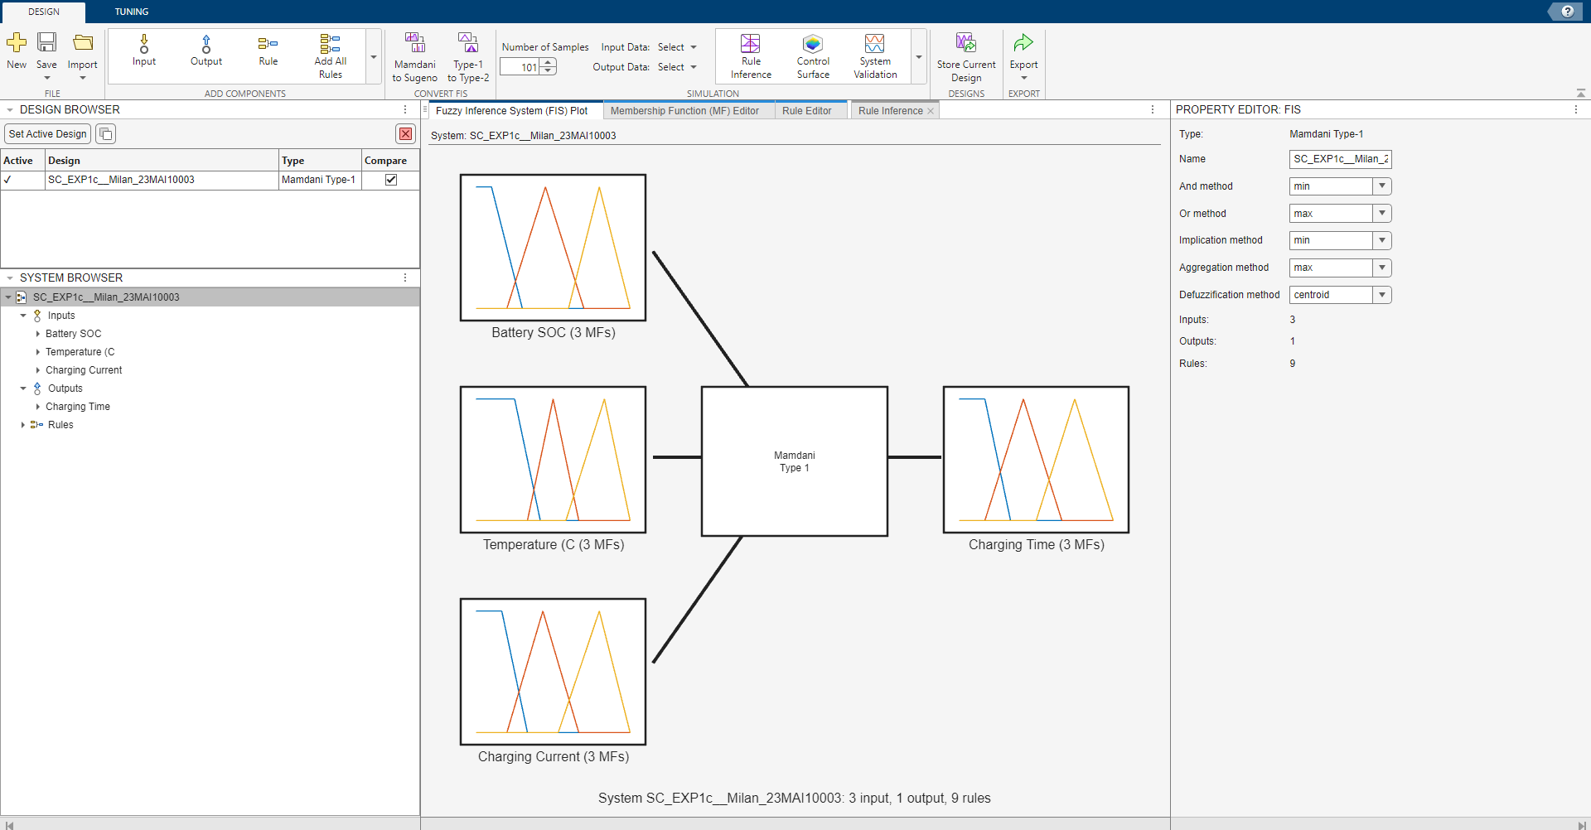

1. Membership Function for each Input and Output-

* MF for Battery SOC -

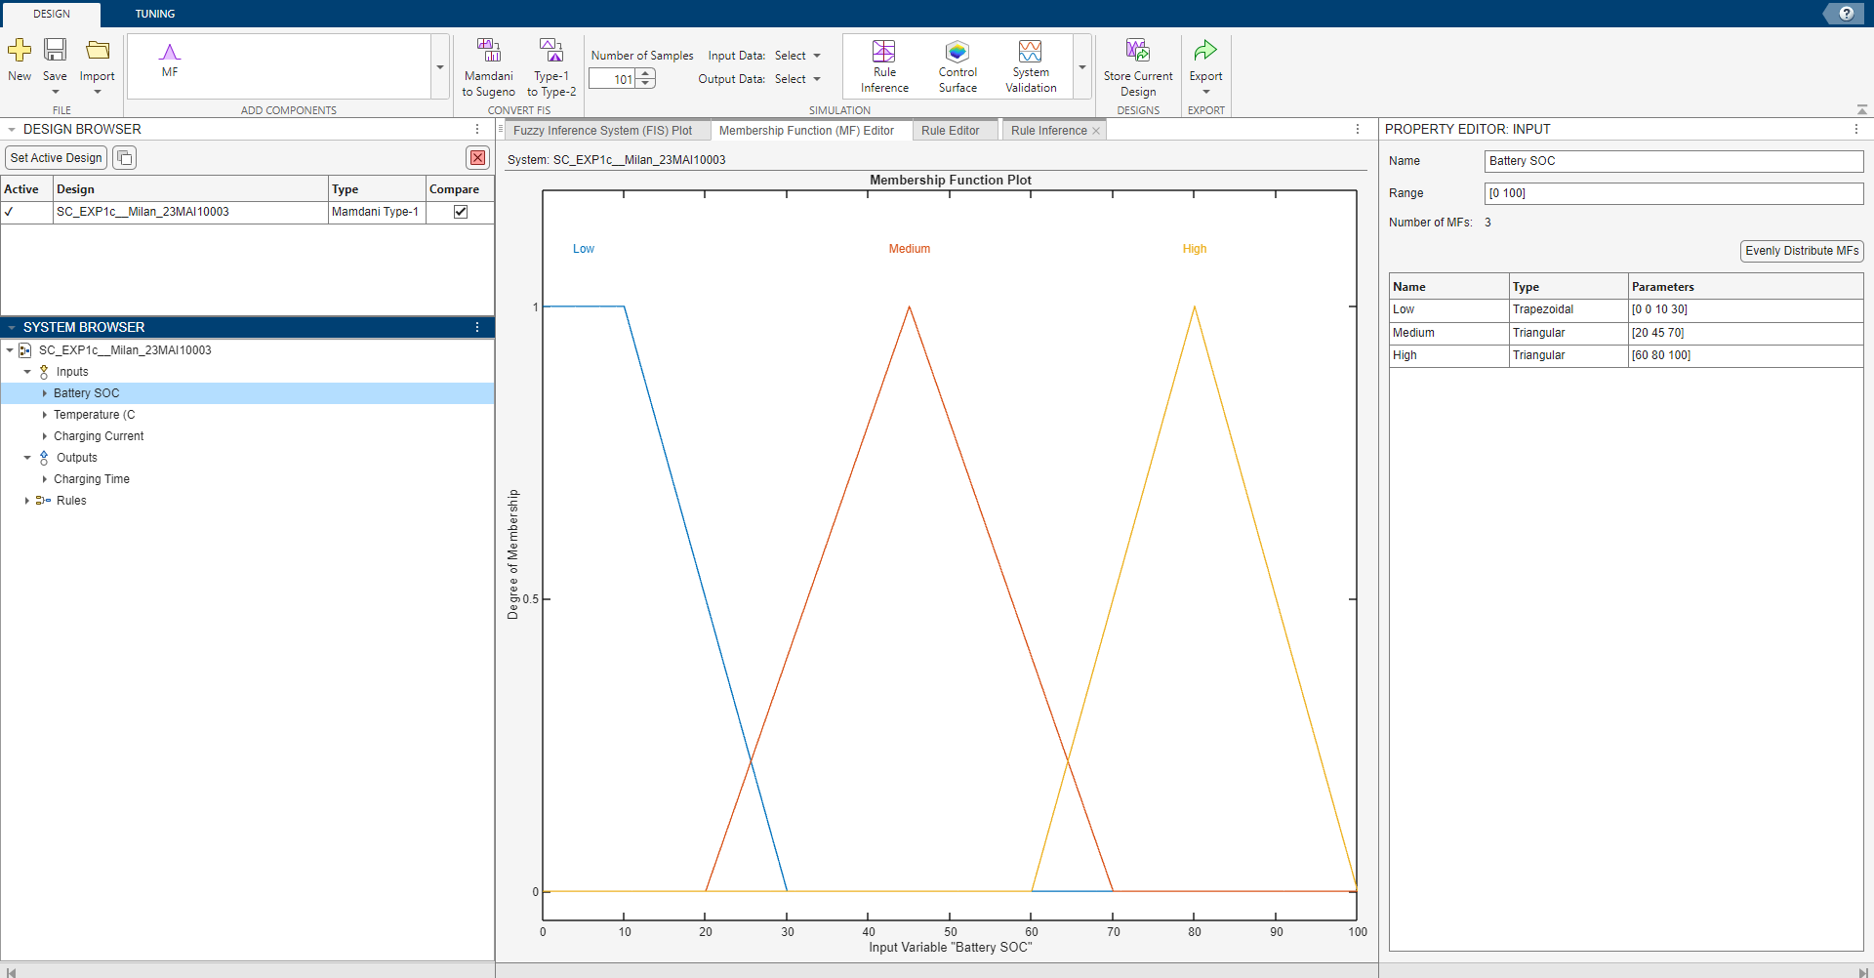

* MF for Temperature in Celcius -

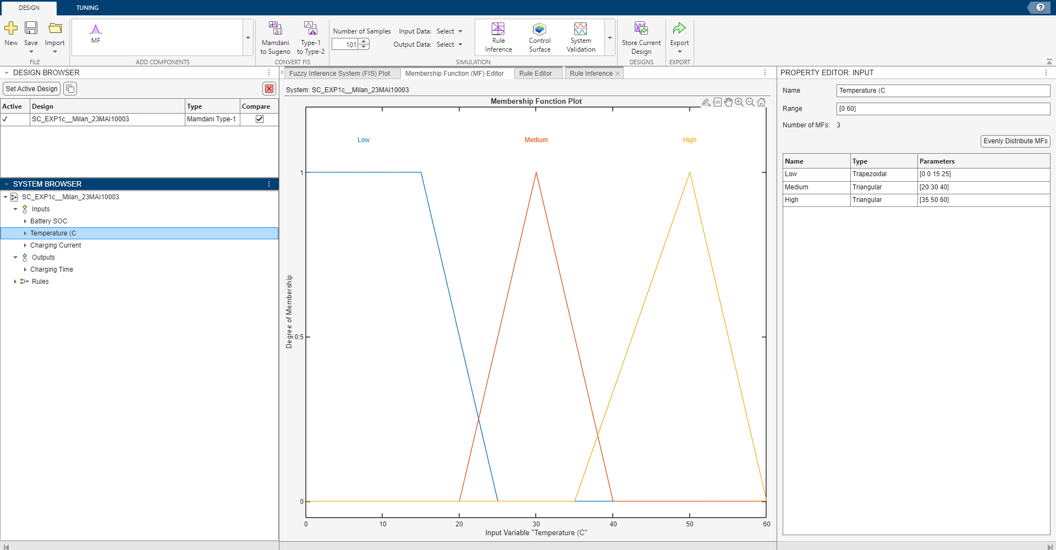

* MF for Charging Current (A) -

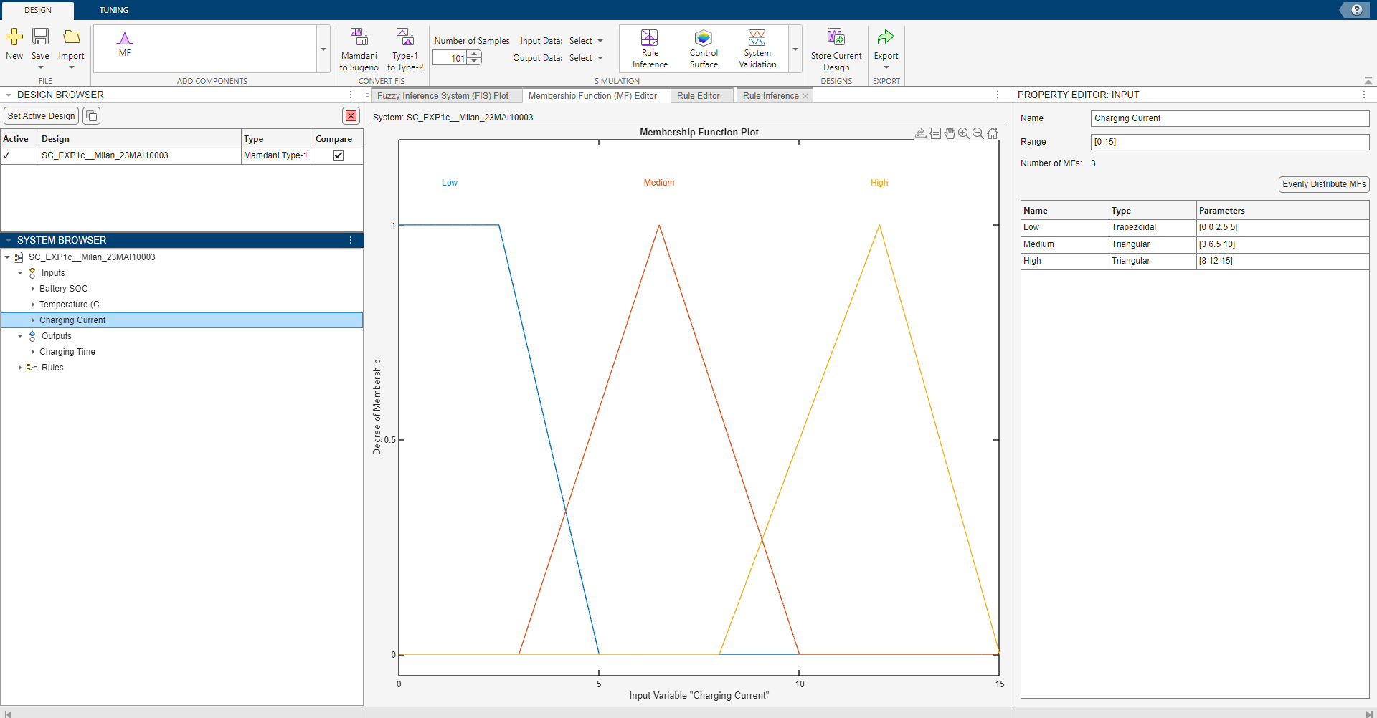

* MF for Charging Time -

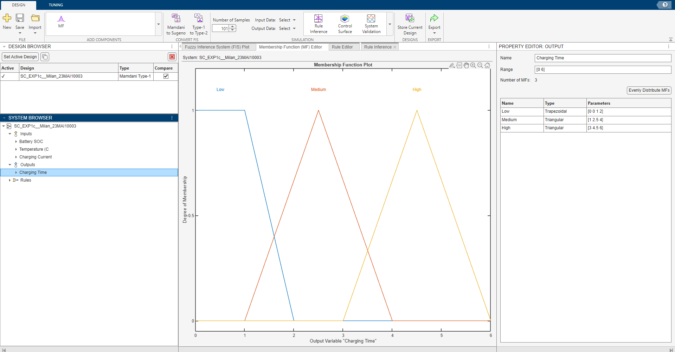

1. Forming Rule Base –

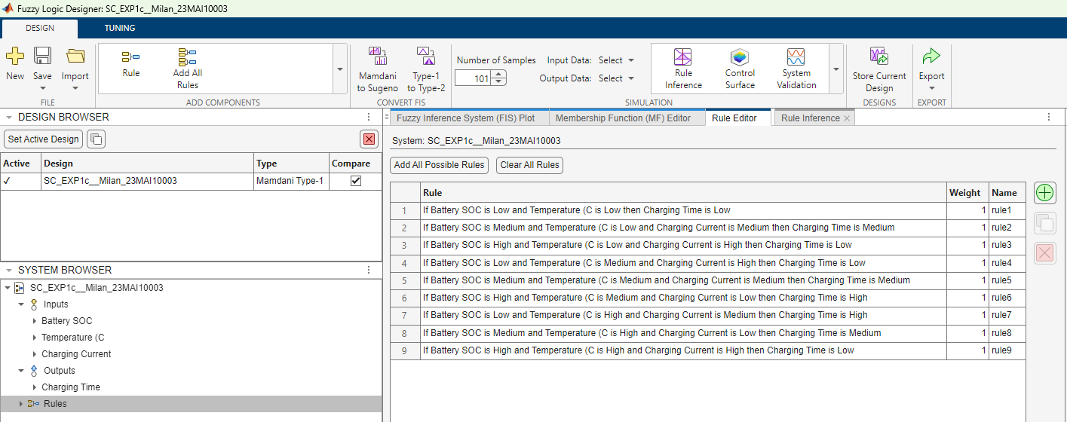

1. Evaluation at Battery 50, Temperature 30 and Charging Current is 7.5 –

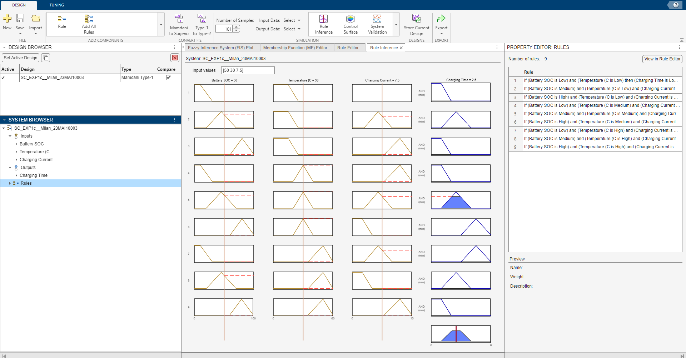

**Learning Outcomes:**

1. I learnt about the fuzzy inference systems used in matlab.
2. I learnt about the working of fuzzy controller.
3. I learnt about the basics of fuzzy logic concepts.
4. I learnt about the basics of conditional fuzzy propositions.
5. I learnt about how to develop intelligent system using fuzzy logic.